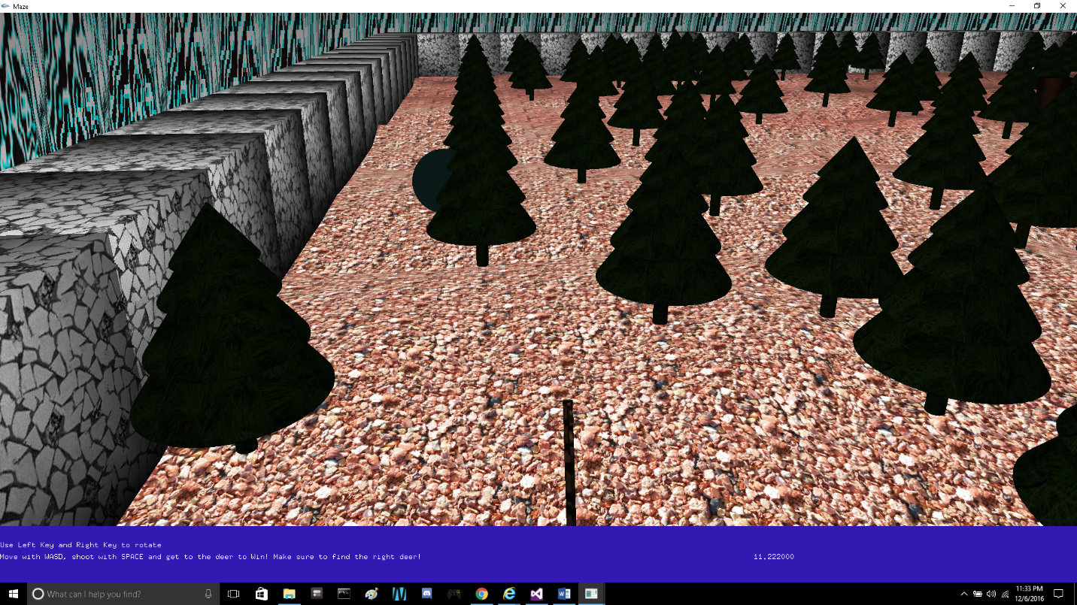

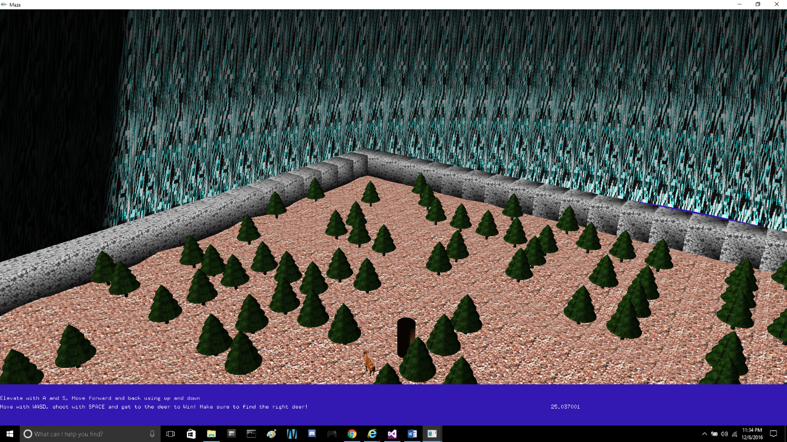

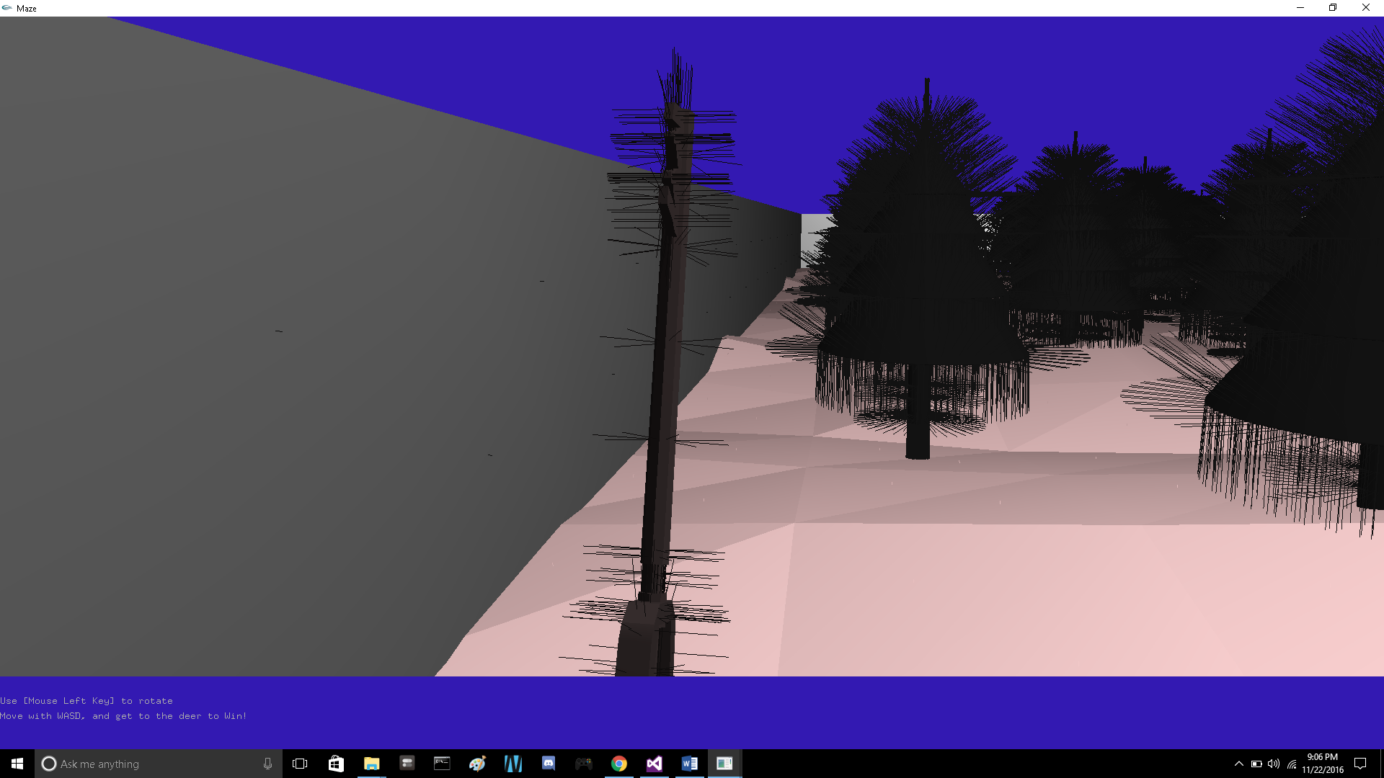

Introduction and Instructions

Welcome to the labyrinth demo written by Antonio Carrion. You are a hunter, use your keyblade to hunt down the deer in this forest maze. The executable can be found in the source code folder. You can switch between first person and overview mode. In first person view move with WASD and rotate the camera with the Arrow Keys. You can rise using the up arrow key and the down arrow key. In overview mode rotate the maze using the arrow keys, and the keys elevates the camera above the maze and the a and s keys moves it closer and further away. Going to Light > Control Light lets you control the light with the left and right arrow keys. The instructions always appear at the bottom of the screen. The popup menu has all the options available for this game. There is also a sky dome with marble noise!

Notes

All the materials used are located in the file called Material.cpp. The controls are similar to the assignment specs.

The menu is as follows:

Navigation – Control Light – Control Camera

Light - Static-moving

Viewing – overview – first person – 45 degrees

Normals - PerFace-PerVertex-PerWeight-Visualization>-Perface-Pervertex

Textures - off

Materials - Same-different

Rendering -Smooth-flat

Plane – Flat Plane - Perlin Noise - Marble Noise

Collision –On – OFF

Crease Angles – Off – 35degrees

Acknowledgments

Significant help from:

Jack Douglas

Aaron Lajom

An Ta

Austin Crothers

Thank You guys for all of your help sincerely.

Libraries:

Vector

"stdlib.h"

"imathvec.h"

"glut.h"

"mesh.h"

"math.h"

“material.h”

“material.cpp”